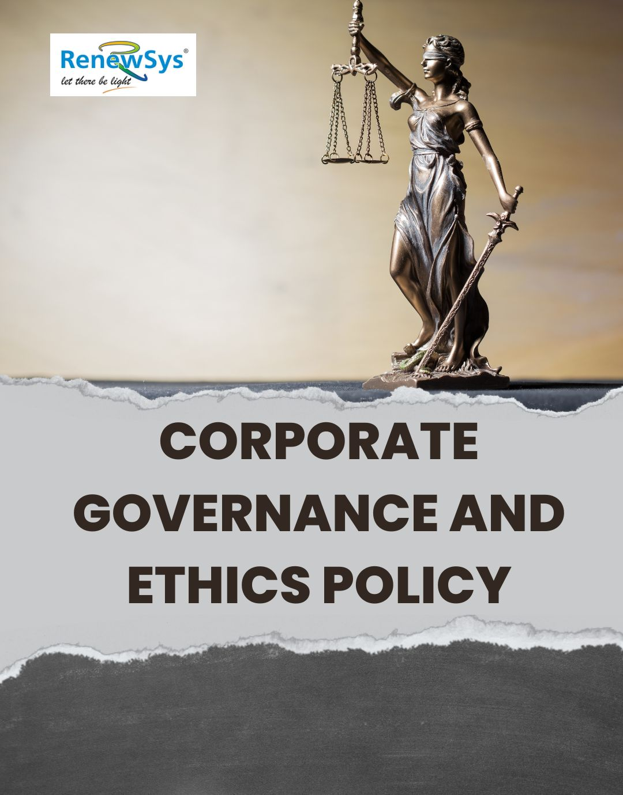

TABLE OF CONTENTS
PREFACE 2
SCOPE 2
POLICY DECLARATION 2
INITIATIVES AND TARGETS IN ALIGNMENT WITH SDGs 3
PERFORMANCE REPORTING RESPONSIBILITIES 4
REPORTING STRUCTURE AND FREQUENCY 5
REVIEW MECHANISM 5

PREFACE

We at RenewSys India Pvt. Ltd. are committed to conduct business in accordance with applicable laws, rules, and regulations, while upholding the highest standards of ethics and integrity. This Corporate Governance and Ethics Policy establishes the principles that guide our operations and foster a culture of accountability and transparency. Our commitment to ethical practices extends to preventing corruption, fraud, money laundering, conflicts of interest, and anti-competitive practices, while safeguarding information security across all our operations.

Every employee is expected to adhere to this policy and integrate ethical principles into their daily activities and decision-making processes. At RenewSys, we believe that strong governance is essential for long-term success and that our business practices should reflect integrity, fairness, and respect for all stakeholders.

SCOPE

This Policy is applicable to following sites and all of its employees, workers, sub-contractors and other stakeholders:

Sr. No. | Site | Address
1 | RenewSys India Pvt. Ltd. | Unit No 607, 6th Floor, Trade Centre, Bandra Kurla Complex, Bandra East- 400051 Mumbai, Maharashtra India
2 | RenewSys India Pvt. Ltd. | Plot No. E-141, Additional Patalganga MIDC Industrial Area, Village - Karade Khurd, Taluka Panvel, District Raigad, Maharashtra - 410 206, India.
3 | RenewSys India Pvt. Ltd. | Plot No. 6, Survey # 114/P,  Srinagar Village, Maheshwaram Mandal, Rangareddy Dist. - 501 359,Telangana, India.

POLICY DECLARATION

Our commitment extends to promoting ethical conduct, enhancing transparency, and ensuring compliance with all applicable laws and regulations. We aim for continuous improvement in our governance practices through employee training, clear communication, and robust reporting mechanisms. By fostering a culture of integrity and accountability, we will strengthen stakeholder trust and drive sustainable business practices. Our baseline for evaluating and tracking progress in corporate governance and ethics initiatives is set for 2022-23.

INITIATIVES AND TARGETS IN ALIGNMENT WITH SDGs

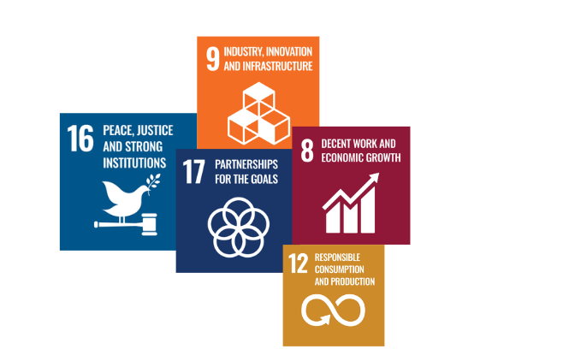

- To promote an organizational culture that prioritizes ethical behavior by integrating anti-corruption values into onboarding processes, employee handbooks and strictly implementing them in all the company’s transactions.
- Maitain zero substantiated corruption complaints, validated through external audits.
- Conduct third-party audits of business practices related to anti-corruption measures annually, maintaining a compliance rate of 100% by 2029-30.
- Foster a culture of transparency by encouraging open communication about potential conflicts of interest without fear of retaliation.
- To maintain 100% employee awareness rate of the conflict of interest reporting process as measured through surveys by year 2029-30.
- To regularly resolve 100% of declared conflicts of interest within 30 days of identification by year 2029-30.
- Maintain enforcement of stringent internal controls like Segregation of duties, regular reconciliation and access controls to minimize opportunities for fraud.
- Ensure that 100% of employees complete annual training sessions on fraud detection and prevention by 2029-30.
- Implement Know Your Customer (KYC) protocols for 100% of new clients and suppliers.
- Introduce mandatory anti-money laundering (AML) training for all employees handling financial transactions.
- Implement monitoring systems to review 100% of all high-volume transactions by 2029-30.
- Establish a legal review process for all significant mergers, acquisitions, and joint ventures to ensure compliance with competition laws.
- Maintain anti-competitive behavior-related violations to zero by 2029-30 through preventive training.
- To regularly update incident response plans to ensure timely action and recovery in the event of a data breach or cyber security incident.
- Ensure that 100% employees are utilizing multi-factor authentication for all critical systems by 2029-30.
- Ensure that 100% of employees attend cybersecurity awareness training annually.
- Perform security audits on bi-annual basis, ensuring all findings are documented and addressed within 30 days.

CONTINUOUS IMPROVEMENT
RenewSys India Pvt. Ltd. is committed to maintaining the highest standards of corporate governance and ethical conduct in all its operations. Our Corporate Governance and Ethics Policy is designed to align with evolving business practices, regulatory requirements, and societal expectations. The Compliance Officer will conduct an annual review of the policy, incorporating insights from employees, stakeholders, and industry experts, alongside periodic audits and benchmarking against best industry practices. This ensures the policy remains dynamic and responsive to emerging challenges. By fostering a culture of integrity, transparency, and accountability, we empower our employees and leadership to uphold ethical principles in every aspect of their work, ensuring trust and excellence across our organization.

PERFORMANCE REPORTING
To ensure transparency and accountability in our governance initiatives, an annual performance report will be provided detailing our progress and adherence to this policy. This report will include key performance indicators (KPIs) aligned with both the quantitative and qualitative targets established, offering a comprehensive evaluation of our successes, challenges, and opportunities for improvement.
Our reporting will encompass various critical areas, including:
- Progress on anti-corruption and fraud prevention initiatives
- Compliance with conflict of interest and transparency standards
- Effectiveness of internal controls and risk management measures
- Employee training and awareness programs related to ethics and governance
- Engagement with external stakeholders regarding governance practices
Additionally, the results of our annual employee surveys, internal audit findings, and compliance assessments will be published by the Compliance and Audit Department and made accessible to all stakeholders, including employees, shareholders, suppliers, and external partners. This ensures that all parties remain informed and engaged in our commitment to corporate governance and ethical standards.

RESPONSIBILITIES
The Compliance Officer will be responsible for compiling and preparing the annual corporate governance and ethics performance report. This will be done in coordination with the reportings given by the following:
- The Compliance Officer for anti-corruption and fraud metrics
- The Internal Audit Team for audit findings and compliance data
- The Human Resources Department for reporting on employee training and awareness initiatives
- The Risk Management Committee for updates on risk mitigation efforts and internal controls

ADDRESSING POLICY VIOLATIONS

RenewSys India Pvt. Ltd. is committed to addressing policy violations with utmost seriousness to uphold the highest standards of ethical conduct. Corrective actions may include verbal or written warnings for minor infractions, probation or suspension for repeated offenses, and immediate termination for serious violations such as fraud, bribery, or harassment. Furthermore, legal proceedings may be initiated in cases of unlawful activities. These measures reinforce accountability and act as a strong deterrent against unethical practices, ensuring trust and integrity throughout the organization and among stakeholders.

REVIEW MECHANISM
The Corporate Governance and Ethics Policy will undergo an annual review led by the Chief Compliance Officer to ensure its relevance and effectiveness. This review will evaluate the policy’s alignment with current legal frameworks, industry standards, and the company’s strategic goals. It will include an assessment of policy implementation, monitoring of ethical compliance, and feedback from internal audits and external stakeholders. Based on the findings, revisions or updates will be made to strengthen governance practices, address emerging risks, and ensure continued adherence to ethical principles across all business operations.

REV. No. 01

EFFECTIVE FROM: 01.05.2024 NEXT REVIEW DATE: 01.05.2025
APPROVED BY:

EMPLOYEE ACKNOWLEGEMNT

I, the undersigned, confirm that I have received, read, and understood the Corporate Governance and Ethics Policy of RenewSys India Pvt. Ltd. I pledge to adhere to the guidelines set forth in the policy and to uphold the principles of integrity, transparency, and ethical behavior it embodies. I acknowledge that any violation of this policy may result in corrective actions, including warnings, suspension, or termination, depending on the nature and severity of the breach. I also commit to reporting any unethical behavior I become aware of and to actively participate in training and awareness programs as required by the company.

Sr. no. | Employee Name | Employee Designation / Department | Employee Signature

